***CLO #:1 Explain key concepts of information security such as design principles, cryptography, risk management***

**Q1):** A web application uses the following PHP code to search for products in a database based on a category selected by the user.

**$category = $_POST['category'];**

**$query = "SELECT id, name, price FROM products WHERE category = '" . $category . "' AND active = 1;";**

**$result = mysqli_query($conn, $query);**

1. Explain how this query is vulnerable to SQL Injection. Describe the specific risk this vulnerability poses to the application. [3 marks]

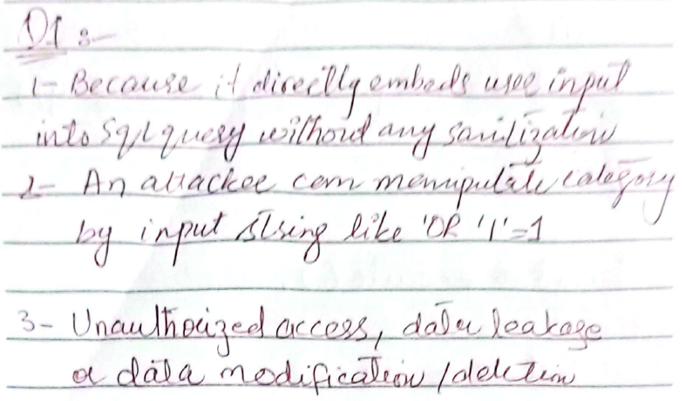

1. Rewrite the vulnerable query using a parameterized statement (also known as a prepared statement) to eliminate the SQL Injection vulnerability. [5 marks]

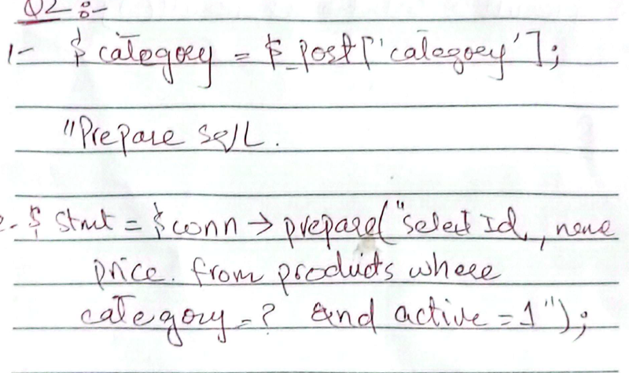

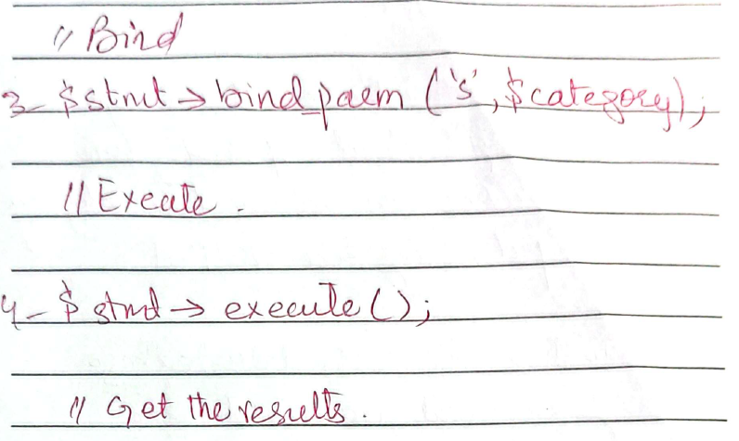

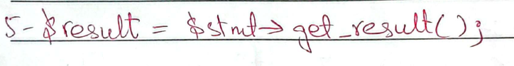

**Q2):**  A Hill Cipher uses a 2×2 key matrix $K=\left[\begin{matrix}3 & 2 \\ 5 & 7\end{matrix}\right]$ . Calculate the ciphertext vector for "HI" using the Hill Cipher encryption. Show your multiplication matrix steps. Note: A=0 and B=1…..Z=25[4 marks]

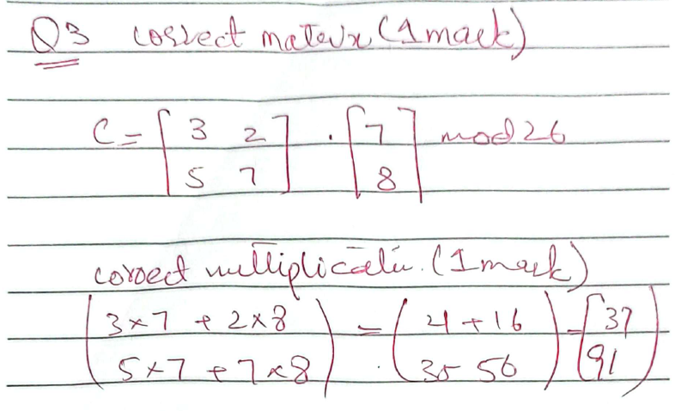  
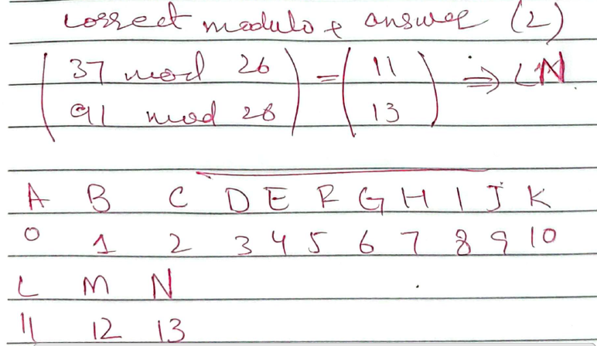

**Q3):** The ciphertext "HLOOLWREDHLO" was encrypted using a row transposition cipher with the key 3142. Determine the original plaintext by performing decryption. Show your grid filling process. Note: A=0 and B=1…..Z=25 [3 marks]

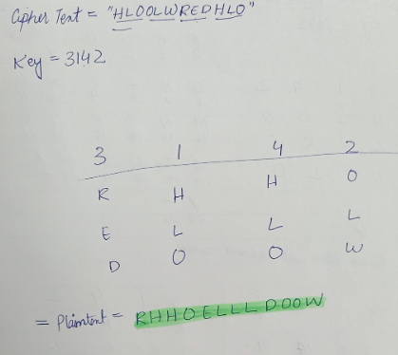

***CLO #:4 Identify appropriate techniques to tackle and solve problems of real life in the discipline of information security***

**Q4:** In AES-128, the original 128-bit key is represented as a 4×4 matrix of bytes (Key5), which is then expanded to generate round keys. The sixth round key (Key6) is derived using the key expansion algorithm. Given the following Key-5 matrix (in hexadecimal) and where W20, W21, W22, and W23 represent the four 32-bit words (columns) of Key-5. [15 Marks]

W20 W21 W22 W23

2B 6F 3A 8C

5E 7D 12 45

A3 1F 9B 67

D4 C2 E8 F1

**Calculate ONLY the first word (W24) of Key-6.**

**S-BOX:**

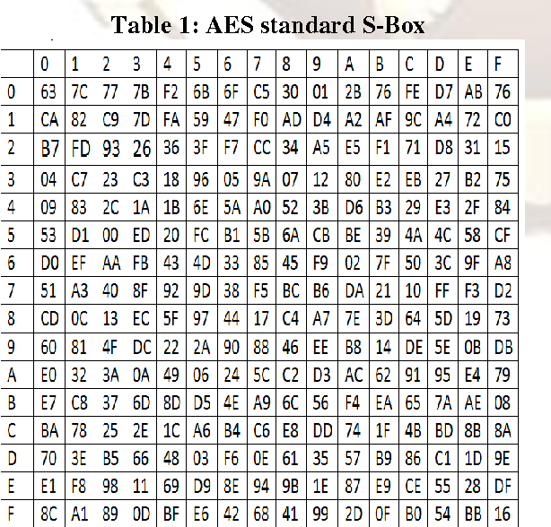

**RCON matrix:**

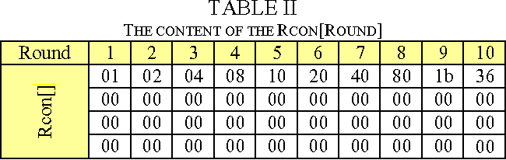





**Q5:** An attacker (Haris) performs a meet-in-the-middle attack on Double DES using one known plaintext–ciphertext pair. Each DES key is 56 bits long. [4+6=10 Marks]

**Note: Only mathematical justifications are acceptable in the following questions.**

1. How many operations would a naive brute-force attack on Double DES require?

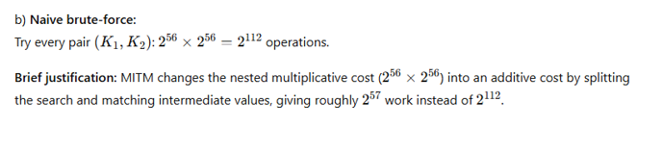

1. How many encryption/decryption operations are required by the meet-in-the-middle attack?

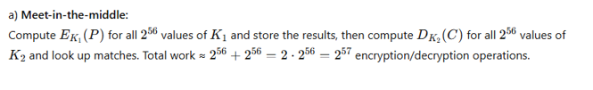

**Q6:** Suppose you have a 16-bit input block instead of a 32-bit block in the DES cryptosystem.

Apply a simplified Expansion Box on the following input to expand it into 24 bits.

R = 0110110110101110 [7 Marks]

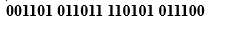

***CLO #:3 Analyze real world scenarios, model them using security measures, and apply various security and risk management tools for achieving information security and privacy***

**Q7:** Jerry and Tipu attempt a Diffie–Hellman key exchange using the following public parameters: prime number *p* = 13 and a primitive root α = 4. Jerry selects his private key XJ = 5 and Tipu selects his private key XT = 7. They compute their public keys as follows: Jerry’s public key PJ=10 and and Tipu’s public key PT= 4. Finally, both calculate the shared secret key as K=10, obtaining the same result on both sides (already calculated with correct formulas). However, their security analyst, Mr. Rafay, points out that there is a flaw in the mathematical setup that weakens the security of the key exchange and makes it more vulnerable to attacks.

**Task:** Identify and Correct the issue highlighted by Mr. Rafay. Explain how it affects the security and overall strength of the Diffie–Hellman key exchange? [13 Marks]

**Note: Only mathematical justifications are acceptable in the above question.**

